COVID-19 Vaccinations Trend Analysis

# Aim:

# The primary aim of this project is to analyze the country vaccination dataset to understand the total vaccinations available by country wise, fully vaccinated people, one dose vaccinated people, data trends and insight by date to understand the distribution and reach of vaccination efforts worldwide.

## **Introduction:** The main objective of this project is to analyse the data on, COVID-19 Vaccinations. We can find out some important insights by analysing the data,.

# ****Problem Statement:****

* In order to know how many people are full vaccinated and atleast one dose vaccinated by country wise.
* The different vaccines used and their availability to different countries.
* To know daily vaccination availability and per day how many people vaccinated by year, month and date.

# ****Methodology:****

The dataset used is available for the public and which is collected from the respective health departments of the countries and from the WHO. The dataset contains information for the period December 2020 to March 2022.

Step 1: Data Exploration  
In order to take any necessary steps we must understand the data we have, which is data exploration and based on our   
understanding we can go ahead with the appropriate data cleaning steps required

Step 2: Data Importing

To Import the data into Power BI, Let’s start with the Get Data option under the home tab. As this is a CSV file, select the Text/CSV option from the drop-down list and the select the file named. After selecting the file, data will be displayed Click on Load and save data.

Step 2: Data cleaning  
I have used Power BI tool to clean and transform the data as per my understanding and I have replaced values, grouped the data and created a new table where it seemed fit.

Step 3: Data Visualization  
I have used Power BI tool to visualize the data available to gain meaningful insights and better understand the dataset. I have used different visualizations like bar graphs, line graphs which are available in the tool.

# Analysis:

The dataset contains the following columns

1. Country – The name of the countries (223 Countries in total)
2. ISO Code – Code initials for the countries
3. Date – The date, month and year of the data collected
4. Total vaccinations – The total number of vaccinations administered which is nothing but the sum of the doses given on any particular date to the total vaccinations of the previous day.
5. People vaccinated – The total number of people who received at least one dose of vaccine. This is also an aggregated column meaning it is the sum of total of the previous day to the vaccinations of the present day.
6. People fully vaccinated – The aggregated value of people who received the desired number of doses (min 2 doses and 1 booster dose may or may not be included).
7. Daily Vaccinations Raw – gives the raw data collected on vaccinations
8. Daily vaccinations – The vaccinations administered on any particular day
9. Total vaccinations per 100 – The total vaccinations administered per 100 people which also an aggregated data
10. People vaccinated per 100 – The number of people who received at least one dose of vaccine, taking into account for every 100 people
11. People fully vaccinated per 100 – For every 100 people how many are fully vaccinated (received min 2 doses)
12. Daily vaccinations per million – gives the number of vaccinations administered for every million population on any particular day.
13. Vaccines – gives the different vaccines and their manufacturers separated by commas.
14. Source name – gives the name of the source from which data is provided.
15. Source website – gives the website link from where the data was obtained.

Now we that what the dataset contains to analyze the data.  
  
in my report page, the card visualization shows that different numeric values like total country, country drop down list, no.of people vaccinated and total vaccination available across world.

* In this we can see that there are 223 countries available in the given dataset.
* 549 billion people fully vaccinated across the world.
* 731 billion people one dose vaccinated across the world.
* 2 TRILLION vaccinations are available across the world.

# My Report page:

1. The slicer is added with country names. If we select particular country from drop down list it will show us number of fully vaccinated people , number of partially vaccinated people overall the country from the year 2020 to 2022.



2. Tree map which shows the vaccine name and its total number of vaccine availability. By each country if we select country from drop down list. Other wise just shows us highest number of vaccine availability to lowest number of vaccine availability.

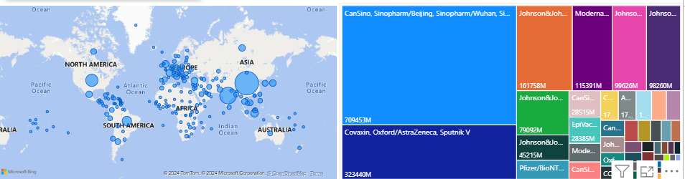

3. Bar chart below shows that Top 10 countries who are fully vaccinated across the globe in the year between 2020 to 2022.

4. Bar chart in right side shows that least 10 countries who are not fully vaccinated across the globe in the year between 2020 to 2022.

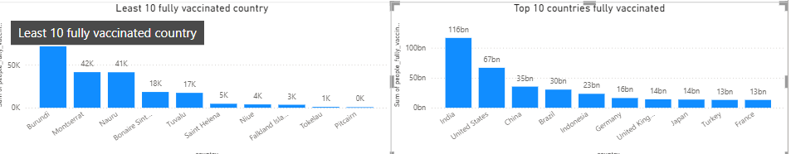

5. In total vaccination per hundred page you can see the year wise area graph viz. Click drill down and double click the particular year, Eg: 2021 year bar. You will get into quarter wise of year 2021. in that again double click on any quarter you will get in to month and day wise. Now move cursor to the bar, it will show in particular day how much vaccination available and number of vaccination available per hundred people for a day wise.

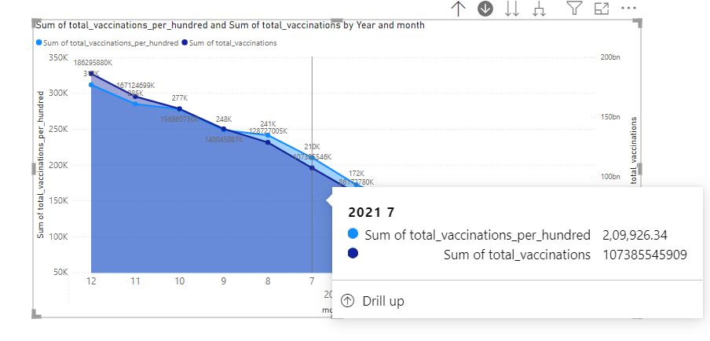

6. Like wise same in daily vaccination page shows number of vaccinations needed is low in starting of 2021 year, and gradually increased need of vaccine in middle of the year to end. In Q2, may 2021 raw vaccination availability is high, but lower in getting vaccinated per million in a day.

7. China has most number of vaccination which is above 7million across the world Its vaccine name is cansino, Sinopharm from Beijing and wuhan from sinovac ZF2001.

8. Finally in the end of the Year 2022, need of vaccination is mostly decreased and most people in each country wise, people gets vaccinated at least one dose.

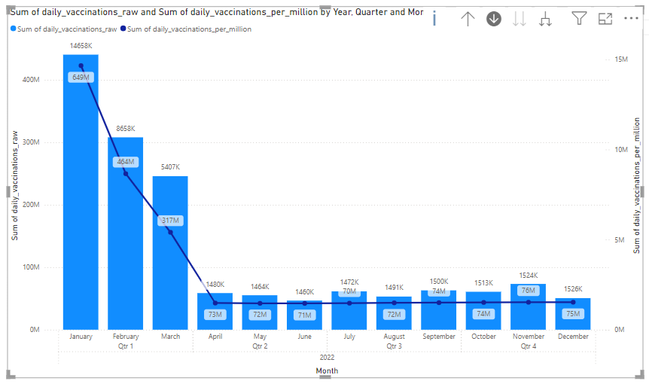

# Insights:

* The final report provides valuable insights gained can guide policy makers, health departments, and international organizations in understanding vaccination trends and addressing challenges in vaccine distribution and uptake.
* The high rate of fully vaccinated individuals indicates a strong global effort to combat COVID-19.

# Recommendation:

1. Targeted Campaigns and Education: Focus on countries with low vaccination rates by implementing targeted campaigns to address vaccine hesitancy and improve distribution logistics, complemented by public education initiatives to combat misinformation.
2. Optimized Distribution: Enhance vaccine supply chains and cold chain management to ensure efficient delivery and storage, especially in rural and underdeveloped areas.
3. Global Cooperation: Strengthen international support through financial and technical aid, facilitate vaccine donations, and promote global collaboration to assist countries with limited resources.
4. Data-Driven Policies: Establish continuous monitoring and analysis systems for vaccination data to inform policy decisions, and invest in research for developing new vaccines and improving existing ones.

# Conclusion:

The analysis of global COVID-19 vaccination data highlights significant progress and disparities in vaccination efforts. Targeted campaigns and improved distribution logistics are essential for increasing vaccination rates in underserved areas. Strengthening global cooperation and utilizing data-driven policies will enhance vaccine delivery and effectiveness. Continued monitoring and research are crucial to adapt strategies and combat the pandemic effectively.

# 